N60-How to upgrade the firmware?
Product line: Wireless Question category: Function configarations

Q: Why do we need to upgrade firmware for the router?
A: Sometimes we may need to upgrade the router to another firmware version if the current firmware version can no longer satisfy your requirement. For example, the new firmware will be of great valve to fix some bugs and to achieve better service.

Warning:
1. Upgrade with Ethernet cable, do not upgrade wirelessly, it may cause failure and damage the router.
2. Do not Power off the router when upgrading
3. Do not upgrade remotely, please just directly connect your PC and router and perform the upgrade.
4. Please make sure you upgrade into a right firmware version. Wrong updates will damage your router.

Ⅰ, Physical connection:
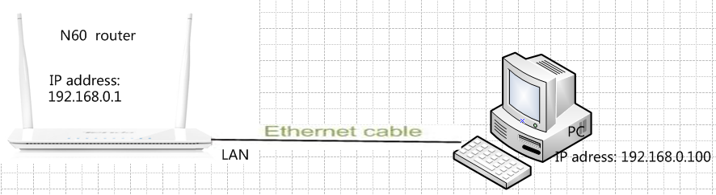

Ⅱ, Download the correctly firmware from our website www.tendacn.com to your computer.

Ⅲ, Please connect your computer to the yellow port of the router with an Ethernet cable, power on your devices.

Ⅳ, Login to the management page of the router:
1、open your web browser(IE,Firefox,Safari,etc) →find the address bar→leave it blank→type http:// 192.168.0.1→Press enter.
- Then input default user name and password:admin, then click login.
- Then click Advanced to go to the router's home page.
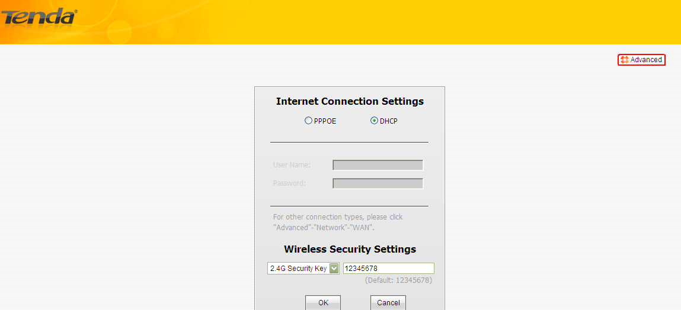
Ⅴ,click Tools→Firmware Upgrade on the left side, then click Browse to Locate and select the firmware, then click Upgrade to upgrade the firmware for the router. The router will reboot after finish upgrading.

